

Vietnamese Study System for Japanese

DETAIL DESIGN DOCUMENT

Class Design

**Project Code: Veazy**

**Document Code: Veazy_Class Design_v1.2_EN**

**Hoa Lac, 16/08/2016**

Record of change

*A - Added M - Modified D – Deleted

|  |  |  |  |  |
| --- | --- | --- | --- | --- |
| **Effective Date** | **Changed Items** | **A* M, D** | **Change Description** | **New Version** |
| 31/07/2016 | Add new | A |  | V1.0 |
| 16/08/2016 | update | M | Update with code change | V1.1 |
| 19/08/2016 | update | M | Update with code change | V1.2 |
| 24/08/2016 | update | M | Update with code change | V1.3 |
|  |  |  |  |  |
|  |  |  |  |  |
|  |  |  |  |  |
|  |  |  |  |  |
|  |  |  |  |  |
|  |  |  |  |  |
|  |  |  |  |  |

SIGNATURE PAGE

**ORIGINATOR:** Dao Thanh Tung 30/07/2016

Developer

**REVIEWERS:**

**APPROVAL:** Nguyen Van Sang

Supervisor

TABLE OF CONTENTS

1 Introduction 8

1.1 Purpose 8

1.2 Definitions, Acronyms and Abbreviations 8

2 Packages 9

2.1 core.common Package 11

2.1.1 Class diagram 11

2.1.2 Const class 12

2.1.3 Utils class 17

2.1.4 JsonUtils class 17

2.1.5 HttpUtils Class 17

2.1.6 HtmlUtils Class 17

2.1.7 MailUtils Class 18

2.1.8 Common Sequence Diagram 19

2.2 core.controller Package 19

2.2.1 Class diagram 19

2.2.2 CoreController Class 20

2.2.3 CourseController Class 20

2.2.4 ExamController Class 20

2.2.5 LessonController Class 21

2.2.6 QuestionController Class 21

2.2.7 ReportController Class 22

2.2.8 StatsController Class 22

2.2.9 UserController Class 22

2.2.10 Sequence Diagram 23

2.3 core.dao Package 23

2.3.1 Class diagram 23

2.3.2 HibernateCourseDao Class 24

2.3.3 HibernateExamDao Class 25

2.3.4 HibernateLessonDao Class 25

2.3.5 HibernateLessonVersionDao Class 26

2.3.6 HibernateQuestionDao Class 26

2.3.7 HibernateReportDao Class 27

2.3.8 HibernateUserDao Class 27

2.3.9 HibernateAnswerDao Class 28

2.3.10 HibernateExamQuestionDao Class 28

2.3.11 Sequence diagram 29

2.4 core.exception Package 29

2.4.1 Class diagram 29

2.4.2 CorruptedFormException Class 30

2.4.3 EmailExpectedException Class 31

2.4.4 InvalidEmailException Class 31

2.4.5 PasswordExpectedException Class 31

2.4.6 PasswordIncorrectException Class 32

2.4.7 UsernameExpectedException Class 32

2.4.8 NullOrEmptyContentException Class 32

2.4.9 Sequence Diagram 32

2.5 core.form Package 33

2.5.1 Class diagram 33

2.5.2 AnswerForm Class 34

2.5.3 ChangeRoleForm Class 34

2.5.4 ChgpwdForm Class 34

2.5.5 CreateExamSinglePartForm Class 35

2.5.6 CreateLessonForm Class 35

2.5.7 ExamPartForm Class 35

2.5.8 FileUploadForm Class 36

2.5.9 LoginForm Class 36

2.5.10 QuestionForm Class 36

2.5.11 RegisterForm Class 36

2.5.12 ReportForm Class 37

2.5.13 SubmitExamForm Class 37

2.5.14 SubmitQuestionForm Class 37

2.5.15 SubmitAnswerForm Class 37

2.5.16 UpdateLessonForm Class 37

2.5.17 UpdateUserForm Class 38

2.5.18 Email Class 39

2.5.19 Sequence Diagram 39

2.6 core.model package 40

2.6.1 Class diagram 40

2.6.2 AnswerModel Class 41

2.6.3 BasicModel Class 41

2.6.4 CourseModel Class 41

2.6.5 ExamAnswer Class 41

2.6.6 ExamModel Class 42

2.6.7 ExamQuestionModel Class 42

2.6.8 LessonModel Class 43

2.6.9 LessonVersionModel Class 43

2.6.10 QuestionModel Class 44

2.6.11 ReportModel Class 44

2.6.12 UserModel Class 45

2.6.13 Sequence Diagram 46

2.7 core.response Package 46

2.7.1 Class diagram 46

2.7.2 AddQuestionResponseData Class 47

2.7.3 AnswerResponse Class 48

2.7.4 BriefAnswerResponse Class 48

2.7.5 BriefLessonResponse Class 48

2.7.6 BriefQuestionResponse Class 49

2.7.7 CreateLessonResponse Class 49

2.7.8 ExamAnswerResponse Class 50

2.7.9 ExamPartResponse Class 50

2.7.10 ExamQuestionResponse Class 50

2.7.11 ExamResultResponse Class 51

2.7.12 ExamSinglePartResponseClass 51

2.7.13 GetCourseResponse Class 51

2.7.14 GetExamResponse Class 52

2.7.15 GetLearnerExamsResponseData Class 52

2.7.16 GetLessonResponse Class 52

2.7.17 GetLessonVersionResponse Class 53

2.7.18 GetListUsersResponseData Class 54

2.7.19 GetUserResponseData Class 54

2.7.20 LoginResponse Class 54

2.7.21 QuestionResponse Class 55

2.7.22 Response Class 55

2.7.23 ResponseCode Class 55

2.7.24 StatsLastExamResponse Class 57

2.7.25 StatsLessonsResponse Class 57

2.7.26 StatsQuestionsResponse Class 57

2.7.27 StatsSkillAvgResponse Class 57

2.7.28 StatsUsersResponse Class 58

2.7.29 UploadFileResponse Class 58

2.7.30 Sequence Diagram 58

2.8 core.security package 59

2.8.1 Class diagram 59

2.8.2 Veazy403Handler Class 60

2.8.3 VeazyAuthenEntryPoint Class 60

2.8.4 VeazyAuthenFailureHandler Class 60

2.8.5 VeazyAuthenFilter Class 60

2.8.6 VeazyAuthenProvider Class 61

2.8.7 VeazyAuthenSuccessHandler Class 61

2.8.8 Sequence Diagram 62

2.9 core.service Package 62

2.9.1 Class diagram 62

2.9.2 CourseServiceImpl Class 63

2.9.3 ExamServiceImpl Class 63

2.9.4 LessonServiceImpl Class 63

2.9.5 QuestionBankServiceImpl Class 64

2.9.6 QuestionServiceImpl Class 64

2.9.7 ReportServiceImpl Class 65

2.9.8 StatsServiceImpl Class 65

2.9.9 UserServiceImpl Class 65

# Introduction

## Purpose

Vietnamese Study System for Japanese class design document contains descriptions of all classes of the Vietnamese Study System for Japanese system. It includes:

* Class diagrams that describe the static relation of all classes in the system.

## Definitions, Acronyms and Abbreviations

|  |  |  |
| --- | --- | --- |
| Abbreviations | Description | Comment |
| MVC | Model View Control model |  |

# C:\Users\MinhNN\Pictures\pkg.pngPackages

**Figure 0: List Packages**

|  |  |  |  |
| --- | --- | --- | --- |
| No | Package | Language | Description |
| 1. 01 | core | JAVA | Contains classes related to core functions |
|  | common | JAVA | Contains common shared classes |
|  | controller | JAVA | Contains Spring controllers |
|  | dao | JAVA | Contains Hibernate data access object classes |
|  | exception | JAVA | Contains user-defined exceptions |
|  | form | JAVA | Contains pojo data forms |
|  | model | JAVA | Contains Spring entity classes |
|  | response | JAVA | Contains data response classes |
|  | security | JAVA | Contain classes related to security |
|  | service | JAVA | Contains Spring service classes |

## core.common Package

### Class diagram

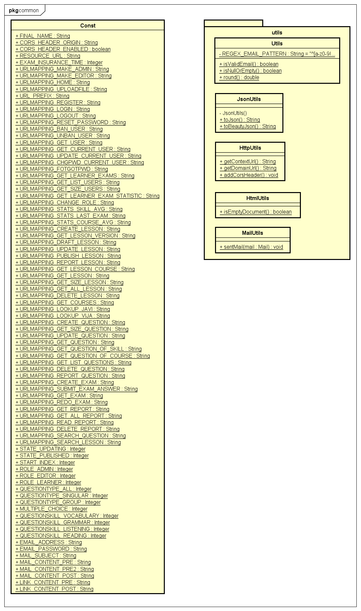

**Figure 1: Class diagram core.common package**

|  |  |  |
| --- | --- | --- |
| No | Class Name | Description |
| 1 | Const | Contain constant variable |
| 2 | Utils | Contain common utility function |
| 3 | JsonUtils | Contain utility function about JSON |
| 4 | HttpUtils | Contain utility function about http |
| 5 | HtmlUtils | Contain utility function about html |
| 6 | MailUtils | Contain utility function about mail |

### Const class

#### Attributes

|  |  |  |  |
| --- | --- | --- | --- |
| No | Attribute | Type | Value |
| 1. 1 | FINAL_NAME | String | Veazy |
|  | CORS_HEADER_ORIGIN | String | Origin |
| 1. 2 | CORS_HEADER_ENABLED | boolean | TRUE |
| 1. 3 | RESOURCE_URL | String | /res |
| 1. 3 | EXAM_INSURANCE_TIME | Integer | 30 |
|  | URLMAPPING_MAKE_ADMIN | String | /mkad/{user_id} |
|  | URLMAPPING_MAKE_EDITOR | String | /mked/{user_id} |
|  | URLMAPPING_HOME | String | / |
|  | URLMAPPING_UPLOADFILE | String | /uploadfile |
|  | URL_PREFIX | String | /api |
|  | URLMAPPING_REGISTER | String | URL_PREFIX + "/register" |
|  | URLMAPPING_LOGIN | String | URL_PREFIX + "/login" |
|  | URLMAPPING_LOGOUT | String | URL_PREFIX + "/logout" |
|  | URLMAPPING_RESET_PASSWORD | String | URL_PREFIX + "/users/reset_password" |
|  | URLMAPPING_BAN_USER | String | URL_PREFIX + "/users/ban/{user_id}" |
|  | URLMAPPING_UNBAN_USER | String | URL_PREFIX + "/users/unban/{user_id}" |
|  | URLMAPPING_GET_USER | String | URL_PREFIX + "/users/{user_id}" |
|  | URLMAPPING_GET_CURRENT_USER | String | URL_PREFIX + "/user" |
|  | URLMAPPING_UPDATE_CURRENT_USER | String | URL_PREFIX + "/user/update" |
|  | URLMAPPING_CHGPWD_CURRENT_USER | String | URL_PREFIX + "/user/chgpwd" |
|  | URLMAPPING_FOTGOTPWD | String | URL_PREFIX + "/user/forgotpwd" |
|  | URLMAPPING_GET_LEARNER_EXAMS | String | URL_PREFIX + "/user/exams" |
|  | URLMAPPING_GET_LIST_USERS | String | URL_PREFIX + "/users" |
|  | URLMAPPING_GET_SIZE_USERS | String | URL_PREFIX + "/users/count" |
|  | URLMAPPING_GET_LEARNER_EXAM_STATISTIC | String | URL_PREFIX + "/users/{user_id}/exams/statistics" |
|  | URLMAPPING_CHANGE_ROLE | String | URL_PREFIX + "/users/change_roll/{user_id}" |
|  | URLMAPPING_STATS_SKILL_AVG | String | URL_PREFIX + "/stats/skill/avg" |
|  | URLMAPPING_STATS_LAST_EXAM | String | URL_PREFIX + "/stats/exam/last/{number}" |
|  | URLMAPPING_STATS_COURSE_AVG | String | URL_PREFIX + "/stats/course/avg" |
|  | URLMAPPING_CREATE_LESSON | String | URL_PREFIX + "/lessons/new" |
|  | URLMAPPING_GET_LESSON_VERSION | String | URL_PREFIX + "/lessons/{lesson_id}/ver{version}" |
|  | URLMAPPING_DRAFT_LESSON | String | URL_PREFIX + "/lessons/savedraft/{lesson_id}" |
|  | URLMAPPING_UPDATE_LESSON | String | URL_PREFIX + "/lessons/update/{lesson_id}" |
|  | URLMAPPING_PUBLISH_LESSON | String | URL_PREFIX + "/lessons/publish/{lesson_id}" |
|  | URLMAPPING_REPORT_LESSON | String | URL_PREFIX + "/lessons/report/{lesson_id}" |
|  | URLMAPPING_GET_LESSON_COURSE | String | URL_PREFIX + "/courses/{course_id}/lessons" |
|  | URLMAPPING_GET_LESSON | String | URL_PREFIX + "/lessons/{lesson_id}" |
|  | URLMAPPING_GET_SIZE_LESSON | String | URL_PREFIX + "/lessons/count" |
|  | URLMAPPING_GET_ALL_LESSON | String | URL_PREFIX + "/lessons" |
|  | URLMAPPING_DELETE_LESSON | String | URL_PREFIX + "/lessons/delete/{lesson_id}" |
|  | URLMAPPING_GET_COURSES | String | URL_PREFIX + "/courses" |
|  | URLMAPPING_LOOKUP_JAVI | String | URL_PREFIX + "/dict/javi/" |
|  | URLMAPPING_LOOKUP_VIJA | String | URL_PREFIX + "/dict/vija/" |
|  | URLMAPPING_CREATE_QUESTION | String | URL_PREFIX + "/questions/new" |
|  | URLMAPPING_GET_SIZE_QUESTION | String | URL_PREFIX + "/questions/count" |
|  | URLMAPPING_UPDATE_QUESTION | String | URL_PREFIX + "/questions/update/{question_id}" |
|  | URLMAPPING_GET_QUESTION | String | URL_PREFIX + "/questions/{question_id}" |
|  | URLMAPPING_GET_QUESTION_OF_SKILL | String | URL_PREFIX + "/skill/{skill_id}/questions" |
|  | URLMAPPING_GET_QUESTION_OF_COURSE | String | URL_PREFIX + "/courses/{course_id}/questions" |
|  | URLMAPPING_GET_LIST_QUESTIONS | String | URL_PREFIX + "/questions" |
|  | URLMAPPING_DELETE_QUESTION | String | URL_PREFIX + "/questions/delete/{question_id}" |
|  | URLMAPPING_REPORT_QUESTION | String | URL_PREFIX + "/questions/report/{question_id}" |
|  | URLMAPPING_CREATE_EXAM | String | URL_PREFIX + "/exams" |
|  | URLMAPPING_SUBMIT_EXAM_ANSWER | String | URL_PREFIX + "/exams/submit" |
|  | URLMAPPING_GET_EXAM | String | URL_PREFIX + "/exams/{exam_id}" |
|  | URLMAPPING_REDO_EXAM | String | URL_PREFIX + "/exams/{exam_id}/redo" |
|  | URLMAPPING_GET_REPORT | String | URL_PREFIX + "/report/get/{report_id}" |
|  | URLMAPPING_GET_ALL_REPORT | String | URL_PREFIX + "/report/all" |
|  | URLMAPPING_READ_REPORT | String | URL_PREFIX + "/report/read/{report_id}" |
|  | URLMAPPING_DELETE_REPORT | String | URL_PREFIX + "/report/delete/{report_id}" |
|  | URLMAPPING_SEARCH_QUESTION | String | URL_PREFIX + "/search/question" |
|  | URLMAPPING_SEARCH_LESSON | String | URL_PREFIX + "/search/lesson" |
|  | UPDATING | Integer | 1 |
|  | PUBLISHED | Integer | 2 |
|  | START_INDEX | Integer | 1 |
|  | ROLE_ADMIN | Integer | 1 |
|  | ROLE_EDITOR | Integer | 2 |
|  | ROLE_LEARNER | Integer | 3 |
|  | QUESTIONTYPE_ALL | Integer | 0 |
|  | QUESTIONTYPE_SINGULAR | Integer | 1 |
|  | QUESTIONTYPE_GROUP | Integer | 2 |
|  | MULTIPLE_CHOICE | Integer | 1 |
|  | QUESTIONSKILL_VOCABULARY | Integer | 1 |
|  | QUESTIONSKILL_GRAMMAR | Integer | 2 |
|  | QUESTIONSKILL_LISTENING | Integer | 3 |
|  | QUESTIONSKILL_READING | Integer | 4 |
|  | EMAIL_ADDRESS | String | veazysystem@gmail.com |
|  | EMAIL_PASSWORD | String | veazy123 |
|  | MAIL_SUBJECT | String | Veazy Reset Password |
|  | MAIL_CONTENT_PRE | String | Hey |
|  | MAIL_CONTENT_PRE2 | String | ,\nSomeone has requested a new password for your Veazy account.\n |
|  | MAIL_CONTENT_POST | String | If you didn't make this request then you can safely ignore this email.\nBest,\n\nThe Veazy Team |
|  | LINK_CONTENT_PRE | String | <a href=\" |
|  | LINK_CONTENT_PRE | String | \">Reset Password</a> |

### Utils class

#### Attributes

|  |  |  |  |  |
| --- | --- | --- | --- | --- |
| No | Attribute | Type | Note | Description |
| 1 | REGEX_EMAIL_PATTERN | String | private | Regex pattern to determine an email |

#### Methods

|  |  |  |
| --- | --- | --- |
| No | Method | Description |
| 1 | isValidEmail() | Check if a string is a valid email or not. |
| 2 | isNullOrEmpty() | Check if a string is null or empty. |
| 3 | round() | round a decimal number |

### JsonUtils class

#### Methods

|  |  |  |
| --- | --- | --- |
| No | Method | Description |
| 1 | toJson() | Convert an object to a json format |
| 2 | toBeautyJson() | Convert an object to a beautiful json format |

### HttpUtils Class

#### Methods

|  |  |  |
| --- | --- | --- |
| No | Method | Description |
| 1 | getContextUrl() | Extracts context url from requested url |
| 2 | addCorsHeader() | Adds CORS headers if enabled |

### HtmlUtils Class

#### Methods

|  |  |  |
| --- | --- | --- |
| No | Method | Description |
| 1 | isEmptyDocument() | Check if Html document is empty |

### MailUtils Class

#### Methods

|  |  |  |
| --- | --- | --- |
| No | Method | Description |
| 1 | sentMail() | Send an email |

### Common Sequence Diagram

## core.controller Package

### Class diagram

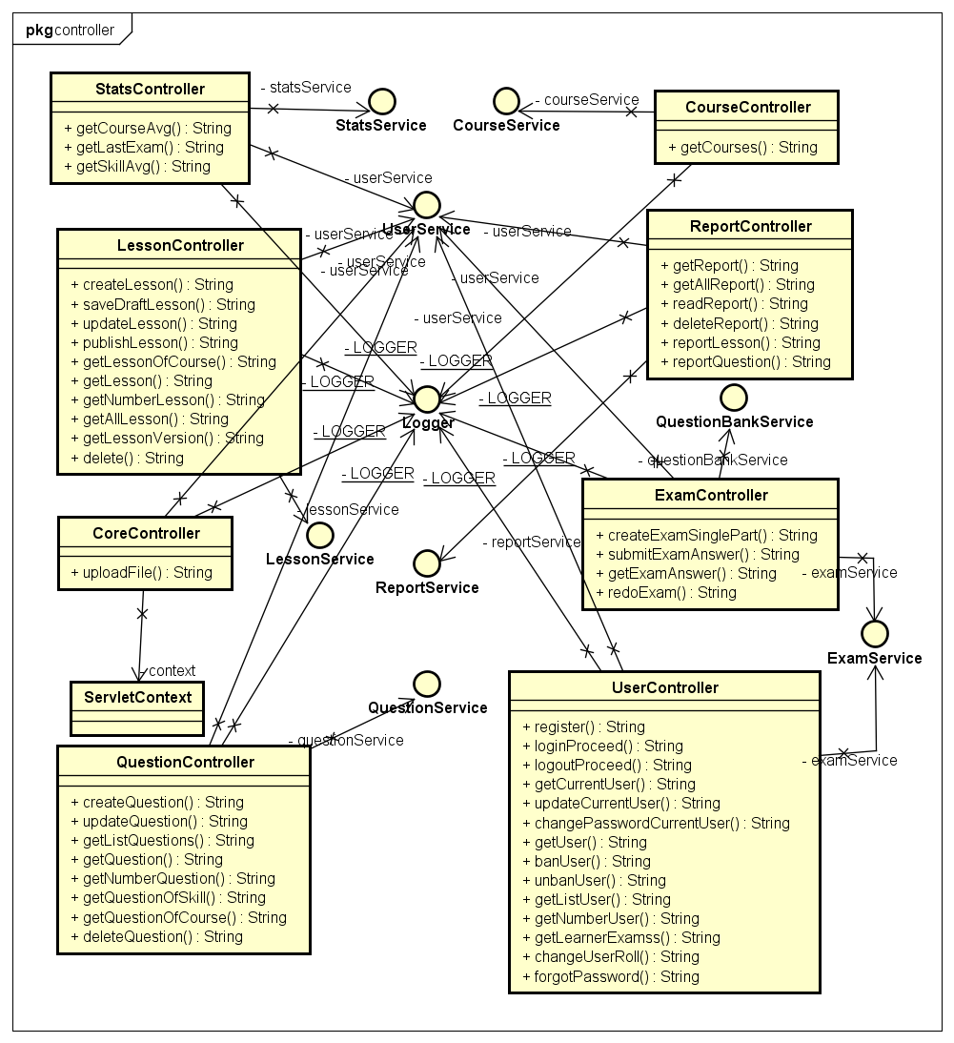

**Figure 2: Class diagram core.controller package**

|  |  |  |
| --- | --- | --- |
| No | Class Name | Description |
| 1 | CoreController | Control core API |
| 2 | CourseController | Control course API |
| 3 | ExamController | Control exam API |
| 4 | LessonController | Control lesson API |
| 5 | QuestionController | Control question API |
| 6 | ReportController | Control report API |
| 8 | StatsController | Control user statistic API |
| 9 | UserController | Control user API |

### CoreController Class

#### Methods

|  |  |  |
| --- | --- | --- |
| No | Method | Description |
| 2 | uploadFile() | To upload file |

### CourseController Class

#### Methods

|  |  |  |
| --- | --- | --- |
| No | Method | Description |
| 1 | getCourses() | Return all courses |

### ExamController Class

#### Methods

|  |  |  |
| --- | --- | --- |
| No | Method | Description |
| 1 | createExamSinglePart() | Generate an exam for learner and return the exam. |
| 2 | submitExamAnswer() | Submit exam answers. |
| 3 | getExamAnswer() | Return the answer of an exam |
| 4 | redoExam() | Return an exam the user had done. |

### LessonController Class

#### Methods

|  |  |  |
| --- | --- | --- |
| No | Method | Description |
| 1 | createLesson | Create a lesson. |
| 2 | saveDraftLesson | Save lesson as draft. |
| 3 | updateLesson | Update a lesson. |
| 4 | publishLesson | Make updating lesson version to publish state. |
| 5 | getLessonOfCourse | Return all lesson of a course. |
| 6 | getLesson | Return a lesson. |
| 7 | getNumberLesson | Return the number of lesson in system. |
| 8 | getAllLesson | Return all lesson of system |
| 9 | getLessonVersion | Return the version of lesson |
| 10 | delete | Delete a lesson |

### QuestionController Class

#### Methods

|  |  |  |
| --- | --- | --- |
| No | Method | Description |
| 1 | createQuestion() | Create a question. |
| 2 | updateQuestion() | Update a question. |
| 3 | getListQuestions() | Return list of question. |
| 4 | getQuestion() | Return a question. |
| 5 | getNumberQuestion() | Return the number of question in system. |
| 6 | getQuestionOfSkill() | Return all question by a skill. |
| 7 | getQuestionOfCourse() | Return all question in a course. |
| 8 | deleteQuestion() | Delete a question. |

### ReportController Class

#### Methods

|  |  |  |
| --- | --- | --- |
| No | Method | Description |
| 1 | getReport () | Return a report |
| 2 | getAllReport () | Return all report |
| 3 | readReport () | Make a report as read state |
| 4 | deleteReport () | Delete a report |
| 5 | reportLesson | Report a lesson. |
| 6 | reportQuestion() | Report a question. |

### StatsController Class

#### Methods

|  |  |  |
| --- | --- | --- |
| No | Method | Description |
| 1 | getCourseAvg | Return the average point of a course. |
| 2 | getLastExam | Return the last exam of user |
| 3 | getSkillAvg | Return the average point of a test skill. |

### UserController Class

#### Methods

|  |  |  |
| --- | --- | --- |
| No | Method | Description |
| 1 | register() | Sign up an account |
| 2 | loginProceed() | Login to system |
| 3 | logoutProceed() | Logout system |
| 4 | getCurrentUser() | Return current user information |
| 5 | updateCurrentUser() | Update user information |
| 6 | changePasswordCurrentUser() | Change password |
| 7 | getUser() | Return an user information |
| 8 | banUser() | Ban a user. |
| 9 | unbanUser() | Unban a user. |
| 10 | getListUser() | Return list of the user. |
| 11 | getNumberUser() | Return the number of user in system. |
| 12 | getLearnerExamss() | Return the done exam of a learner. |
| 13 | changeUserRoll() | Change user role. |

### Sequence Diagram

## core.dao Package

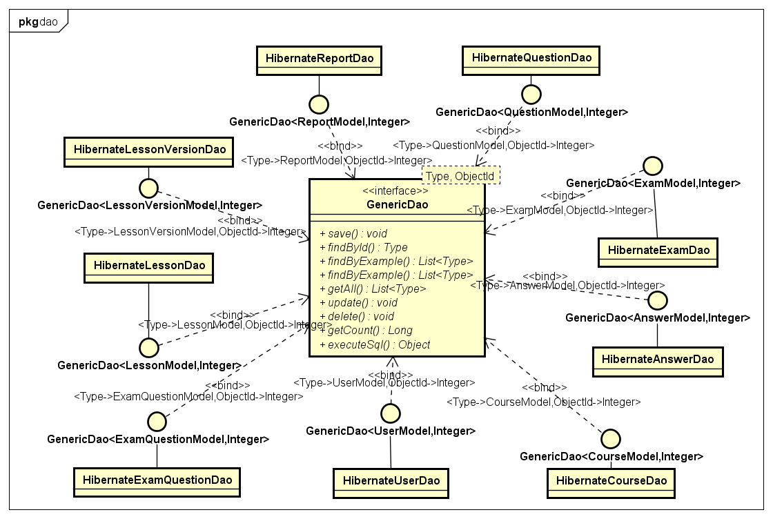

**Figure 3: Class diagram core.dao package**

### Class diagram

|  |  |  |
| --- | --- | --- |
| No | Class Name | Description |
| 1 | HibernateCourseDao | Provides methods to manage course data in database |
| 2 | HibernateExamDao | Provides methods to manage test data in database |
| 3 | HibernateLessonDao | Provides methods to manage lesson data in database |
| 4 | HibernateLessonVersionDao | Provides methods to manage versions of lesson in database |
| 5 | HibernateQuestionDao | Provides methods to manage question data in database |
| 6 | HibernateReportDao | Provides methods to manage report data in database |
| 7 | HibernateUserDao | Provides methods to manage user data in database |
| 8 | HibernateAnswerDao | Provides methods to manage course data in database |
| 9 | HibernateExamQuestionDao | Provides methods to manage test data in database |

### HibernateCourseDao Class

#### Methods

|  |  |  |
| --- | --- | --- |
| No | Method | Description |
| 1 | save() | Save a course to database |
| 2 | findById() | Find a course by its id |
| 3 | findByExample() | Find all course have same feature with example |
| 4 | findByExample() | Find some course have same feature with example |
| 5 | getAll() | Return all course |
| 6 | update() | Update a course |
| 7 | delete() | Delete a course |
| 8 | getCount() | Return the number of the course in database |
| 9 | executeSql() | Return the courses execute by sql |

### HibernateExamDao Class

#### Methods

|  |  |  |
| --- | --- | --- |
| No | Method | Description |
| 1 | save() | Save an exam to database |
| 2 | findById() | Find an exam by its id |
| 3 | findByExample() | Find all exam have same feature with example |
| 4 | findByExample() | Find some exam have same feature with example |
| 5 | getAll() | Return all exam |
| 6 | update() | Update an exam |
| 7 | delete() | Delete an exam |
| 8 | getCount() | Return the number of the exam in database |
| 9 | executeSql() | Return the exams execute by sql |

### HibernateLessonDao Class

#### Methods

|  |  |  |
| --- | --- | --- |
| No | Method | Description |
| 1 | save() | Save a lesson to database |
| 2 | findById() | Find a lesson by its id |
| 3 | findByExample() | Find all lesson have same feature with example |
| 4 | findByExample() | Find some lesson have same feature with example |
| 5 | getAll() | Return all lesson |
| 6 | update() | Update a lesson |
| 7 | delete() | Delete a lesson |
| 8 | getCount() | Return the number of the lesson in database |
| 9 | executeSql() | Return the lessons execute by sql |

### HibernateLessonVersionDao Class

#### Methods

|  |  |  |
| --- | --- | --- |
| No | Method | Description |
| 1 | save() | Save a lesson version to database |
| 2 | findById() | Find a lesson version by its id |
| 3 | findByExample() | Find all lesson version have same feature with example |
| 4 | findByExample() | Find some lesson version have same feature with example |
| 5 | getAll() | Return all lesson version |
| 6 | update() | Update a lesson version |
| 7 | delete() | Delete a lesson version |
| 8 | getCount() | Return the number of the lesson version in database |
| 9 | executeSql() | Return the lesson versions execute by sql |

### HibernateQuestionDao Class

#### Methods

|  |  |  |
| --- | --- | --- |
| No | Method | Description |
| 1 | save() | Save a question to database |
| 2 | findById() | Find a question by its id |
| 3 | findByExample() | Find all question have same feature with example |
| 4 | findByExample() | Find some question have same feature with example |
| 5 | getAll() | Return all question |
| 6 | update() | Update a question |
| 7 | delete() | Delete a question |
| 8 | getCount() | Return the number of the question in database |
| 9 | executeSql() | Return the questions execute by sql |

### HibernateReportDao Class

#### Methods

|  |  |  |
| --- | --- | --- |
| No | Method | Description |
| 1 | save() | Save a report to database |
| 2 | findById() | Find a report by its id |
| 3 | findByExample() | Find all report have same feature with example |
| 4 | findByExample() | Find some report have same feature with example |
| 5 | getAll() | Return all report |
| 6 | update() | Update a report |
| 7 | delete() | Delete a report |
| 8 | getCount() | Return the number of the report in database |
| 9 | executeSql() | Return the reports execute by sql |

### HibernateUserDao Class

#### Methods

|  |  |  |
| --- | --- | --- |
| No | Method | Description |
| 1 | save() | Save an account to database |
| 2 | findById() | Find an account by its id |
| 3 | findByExample() | Find all account have same feature with example |
| 4 | findByExample() | Find some account have same feature with example |
| 5 | getAll() | Return all account |
| 6 | update() | Update an account |
| 7 | delete() | Delete an account |
| 8 | getCount() | Return the number of the account in database |
| 9 | executeSql() | Return the accounts execute by sql |

### HibernateAnswerDao Class

#### Methods

|  |  |  |
| --- | --- | --- |
| No | Method | Description |
| 1 | save() | Save an answer to database |
| 2 | findById() | Find an answer by its id |
| 3 | findByExample() | Find all answer have same feature with example |
| 4 | findByExample() | Find some answer have same feature with example |
| 5 | getAll() | Return all answer |
| 6 | update() | Update an answer |
| 7 | delete() | Delete an answer |
| 8 | getCount() | Return the number of the answer in database |
| 9 | executeSql() | Return the answer execute by sql |

### HibernateExamQuestionDao Class

#### Methods

|  |  |  |
| --- | --- | --- |
| No | Method | Description |
| 1 | save() | Save an exam question to database |
| 2 | findById() | Find an exam question by its id |
| 3 | findByExample() | Find all exam question have same feature with example |
| 4 | findByExample() | Find some exam question have same feature with example |
| 5 | getAll() | Return all exam question |
| 6 | update() | Update an exam question |
| 7 | delete() | Delete an exam question |
| 8 | getCount() | Return the number of the exam question in database |
| 9 | executeSql() | Return the exam questions execute by sql |

### Sequence diagram

## core.exception Package

### C:\Users\CuHo\Desktop\Exception.pngClass diagram

***Figure 4: Class diagram Practice core.exception package***

|  |  |  |
| --- | --- | --- |
| No | Class Name | Description |
| 1 | CorruptedFormException | Exception throwed when user submitted a corrupted form i.e. form that does not have enough expected data |
| 2 | EmailExpectedException | Exception throwed when submitted form does not contain email |
| 3 | InvalidEmailException | Exception throwed when submitted form contains invalid email |
| 4 | PasswordExpectedException | Exception throwed when submitted form does not contain password |
| 5 | PasswordIncorrectException | Exception throwed when submitted form contains incorrect username or password |
| 6 | UsernameExpectedException | Exception throwed when submitted form does not contain username |
| 7 | NullOrEmptyContentException | Exception throwed when submitted data is null or empty |

### CorruptedFormException Class

#### Attributes

|  |  |  |  |  |  |
| --- | --- | --- | --- | --- | --- |
| No | Attribute | Type | Default | Note | Description |
| 1 | ERROR_CODE | int |  | private |  |

#### Methods

|  |  |  |
| --- | --- | --- |
| No | Method | Description |
| 1 | getCode() |  |

### EmailExpectedException Class

#### Attributes

|  |  |  |  |  |  |
| --- | --- | --- | --- | --- | --- |
| No | Attribute | Type | Default | Note | Description |
| 1 | ERROR_CODE | int |  | private |  |

#### Methods

|  |  |  |
| --- | --- | --- |
| No | Method | Description |
| 1 | getCode() |  |

### InvalidEmailException Class

#### Attributes

|  |  |  |  |  |  |
| --- | --- | --- | --- | --- | --- |
| No | Attribute | Type | Default | Note | Description |
| 1 | ERROR_CODE | int |  | private |  |

#### Methods

|  |  |  |
| --- | --- | --- |
| No | Method | Description |
| 1 | getCode() |  |

### PasswordExpectedException Class

#### Attributes

|  |  |  |  |  |  |
| --- | --- | --- | --- | --- | --- |
| No | Attribute | Type | Default | Note | Description |
| 1 | ERROR_CODE | int |  | private |  |

#### Methods

|  |  |  |
| --- | --- | --- |
| No | Method | Description |
| 1 | getCode() |  |

### PasswordIncorrectException Class

#### Attributes

|  |  |  |  |  |  |
| --- | --- | --- | --- | --- | --- |
| No | Attribute | Type | Default | Note | Description |
| 1 | ERROR_CODE | int |  | private |  |

#### Methods

|  |  |  |
| --- | --- | --- |
| No | Method | Description |
| 1 | getCode() |  |

### UsernameExpectedException Class

#### Attributes

|  |  |  |  |  |  |
| --- | --- | --- | --- | --- | --- |
| No | Attribute | Type | Default | Note | Description |
| 1 | ERROR_CODE | int |  | private |  |

#### Methods

|  |  |  |
| --- | --- | --- |
| No | Method | Description |
| 1 | getCode() |  |

### NullOrEmptyContentException Class

#### Attributes

|  |  |  |  |  |  |
| --- | --- | --- | --- | --- | --- |
| No | Attribute | Type | Default | Note | Description |
| 1 | ERROR_CODE | int |  | private |  |

#### Methods

|  |  |  |
| --- | --- | --- |
| No | Method | Description |
| 1 | getCode() |  |

### Sequence Diagram

## core.form Package

### C:\Users\CuHo\Desktop\Diagram v2\Form.pngClass diagram

**Figure 5: Class diagram core.form package**

|  |  |  |
| --- | --- | --- |
| No | Class Name | Description |
| 1 | AnswerForm | Answer form |
| 2 | ChangeRoleForm | Change user role form |
| 3 | ChgpwdForm | Change password form |
| 4 | CreateExamSinglePartForm | Create exam form |
| 5 | CreateLessonForm | Create lesson form |
| 6 | ExamPartForm | Form for generating a exam |
| 7 | FileUploadForm | Upload file form |
| 8 | LoginForm | Login form Lookup word form |
| 9 | QuestionForm | Get a question form |
| 10 | RegisterForm | Register form |
| 11 | ReportForm | Report a question or lesson form |
| 12 | SubmitExamForm | Submit an exam |
| 13 | SubmitQuestionForm | Submit questions of an exam |
| 14 | SubmitAnswerForm | Submit answers of a question |
| 15 | UpdateLessonForm | Update question lesson form |
| 16 | UpdateUserForm | Update user form |
| 17 | Mail | Send email form |

### AnswerForm Class

#### Attributes

|  |  |  |  |  |
| --- | --- | --- | --- | --- |
| No | Attribute | Type | Note | Description |
| 1 | answer | String | private | The question answer. |
| 2 | isRight | Boolean | private | The answer is correct or not |

### ChangeRoleForm Class

#### Attributes

|  |  |  |  |  |
| --- | --- | --- | --- | --- |
| No | Attribute | Type | Note | Description |
| 1 | userId | Integer | private | The user id. |
| 2 | role | Integer | private | The new role of user. |

### ChgpwdForm Class

#### Attributes

|  |  |  |  |  |
| --- | --- | --- | --- | --- |
| No | Attribute | Type | Note | Description |
| 1 | oldPassword | String | private | Old password. |
| 2 | newPassword | String | private | New password. |

### CreateExamSinglePartForm Class

#### Attributes

|  |  |  |  |  |
| --- | --- | --- | --- | --- |
| No | Attribute | Type | Note | Description |
| 1 | courseId | Integer | private | The course of the exam |
| 2 | skill | Integer | private | The skill of the exam |
| 3 | numberOfQuestion | Integer | private | The number question of the exam |

### CreateLessonForm Class

#### Attributes

|  |  |  |  |  |
| --- | --- | --- | --- | --- |
| No | Attribute | Type | Note | Description |
| 1 | courseId | Integer | private | The course id of lesson. |
| 2 | lessonTitle | String | private | The lesson title. |
| 3 | description | String | private | The lesson description. |
| 4 | vocabulary | String | private | The lesson vocabulary. |
| 5 | grammar | String | private | The lesson grammar. |
| 6 | reading | String | private | The lesson reading part. |
| 7 | listening | String | private | The lesson listening part. |
| 8 | practice | String | private | The lesson practice part. |
| 9 | article | String | private | The lesson article. |

### ExamPartForm Class

#### Attributes

|  |  |  |  |  |
| --- | --- | --- | --- | --- |
| No | Attribute | Type | Note | Description |
| 1 | skill | int | private | The skill of exam. |
| 2 | numberOfQuestion | int | private | The number of question in exam. |

### FileUploadForm Class

### LoginForm Class

#### Attributes

|  |  |  |  |  |
| --- | --- | --- | --- | --- |
| No | Attribute | Type | Note | Description |
| 1 | username | String | private | The user name. |
| 2 | encryptedPassword | String | private | The user password has been encrypted. |

### QuestionForm Class

#### Attributes

|  |  |  |  |  |
| --- | --- | --- | --- | --- |
| No | Attribute | Type | Note | Description |
| 1 | questionId | Integer | private | The question Id. |
| 2 | questionAnswerType | Integer | private | The question answer type. |
| 3 | questionType | Integer | private | The question type. |
| 4 | questionSkill | Integer | private | The question skill. |
| 5 | courseId | Integer | private | The course id of question. |
| 6 | creatorId | Integer | private | The id of user who create question. |
| 7 | numberOfQuestion | Integer | private | The number of child question. |
| 8 | etaTime | Integer | private | Estimate time to complete the question |
| 9 | question | String | private | The question. |
| 10 | attachment | String | private | The file attach with question |

### RegisterForm Class

#### Attributes

|  |  |  |  |  |
| --- | --- | --- | --- | --- |
| No | Attribute | Type | Note | Description |
| 1 | username | String | private | The user name. |
| 2 | password | String | private | The user password. |
| 3 | email | String | private | The user email. |

### ReportForm Class

#### Attributes

|  |  |  |  |  |
| --- | --- | --- | --- | --- |
| No | Attribute | Type | Note | Description |
| 1 | content | String | private | The report content. |

### SubmitExamForm Class

#### Attributes

|  |  |  |  |  |
| --- | --- | --- | --- | --- |
| No | Attribute | Type | Note | Description |
| 1 | examId | Integer | private | The exam id. |
| 2 | takenTime | Integer | private | The time user do exam. |

### SubmitQuestionForm Class

#### Attributes

|  |  |  |  |  |
| --- | --- | --- | --- | --- |
| No | Attribute | Type | Note | Description |
| 1 | questionId | Integer | private | The question id. |

### SubmitAnswerForm Class

#### Attributes

|  |  |  |  |  |
| --- | --- | --- | --- | --- |
| No | Attribute | Type | Note | Description |
| 1 | answer | String | private | The answer |
| 2 | isSelected | Boolean | private | User select this answer or not |

### UpdateLessonForm Class

#### Attributes

|  |  |  |  |  |
| --- | --- | --- | --- | --- |
| No | Attribute | Type | Note | Description |
| 1 | lessonId | Integer | private | The lesson id |
| 2 | courseId | Integer | private | The course id of lesson. |
| 3 | lessonTitle | String | private | The lesson title. |
| 4 | description | String | private | The lesson description. |
| 5 | vocabulary | String | private | The lesson vocabulary. |
| 6 | grammar | String | private | The lesson grammar. |
| 7 | reading | String | private | The lesson reading part. |
| 8 | listening | String | private | The lesson listening part. |
| 9 | practice | String | private | The lesson practice part. |
| 10 | article | String | private | The lesson article. |

### UpdateUserForm Class

#### Attributes

|  |  |  |  |  |
| --- | --- | --- | --- | --- |
| No | Attribute | Type | Note | Description |
| 1 | firstName | String | private | The user first name. |
| 2 | lastName | String | private | The user last name. |
| 3 | dob | Long | private | date of birth |
| 4 | address | String | private | The user address. |
| 5 | hobby | String | private | The user hobby. |
| 6 | bio | String | private | The user introduction. |
| 7 | website | String | private | The user website. |
| 8 | quote | String | private | Favorite quote |

### Email Class

#### Attributes

|  |  |  |  |  |
| --- | --- | --- | --- | --- |
| No | Attribute | Type | Note | Description |
| 1 | senderEmailAddress | String | private | Email address of sender |
| 2 | senderPassword | String | private | Password of sender |
| 3 | receiverEmailAddress | String | private | Email address of receiver |
| 4 | emailSubject | String | private | Email subject |
| 5 | emailContent | String | private | Email content |
| 6 | emailContentType | String | private | Email content type |

### Sequence Diagram

## core.model package

### Class diagram

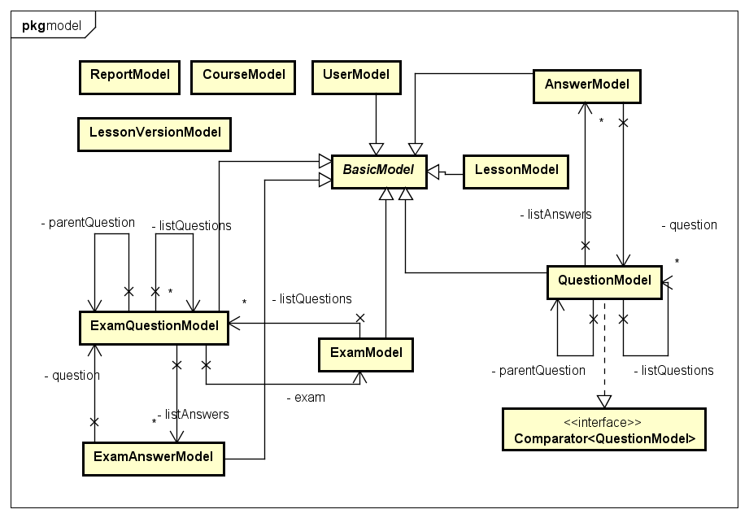

**Figure 6: Class diagram core.model package**

|  |  |  |
| --- | --- | --- |
| No | Class Name | Description |
| 1 | AnswerModel | Answer model |
| 2 | BasicModel | Basic model |
| 3 | CourseModel | Course model |
| 4 | ExamAnswerModel | Exam answer |
| 5 | ExamModel | Exam model |
| 6 | ExamQuestionModel | Exam question model |
| 7 | LessonModel | Lesson model |
| 8 | LessonVersionModel | Lesson version model |
| 9 | QuestionModel | Question model |
| 10 | ReportModel | Report model |
| 11 | UserModel | User model |

### AnswerModel Class

#### Attributes

|  |  |  |  |  |
| --- | --- | --- | --- | --- |
| No | Attribute | Type | Note | Description |
| 1 | answer | String | private | The question answer. |
| 2 | isRight | Boolean | private | The answer is correct or not |

### BasicModel Class

#### Attributes

|  |  |  |  |  |
| --- | --- | --- | --- | --- |
| No | Attribute | Type | Note | Description |
| 1 | id | Integer | private | The model id |
| 2 | createDate | Long | private | The date model is created |
| 3 | updateDate | Long | private | The last update date |
| 4 | deleteDate | Long | private | The date model is deleted |
| 5 | deleteFlag | Boolean | private | The model is deleted or not |

### CourseModel Class

#### Attributes

|  |  |  |  |  |
| --- | --- | --- | --- | --- |
| No | Attribute | Type | Note | Description |
| 1 | id | Integer | private | The course id |
| 2 | name | String | private | The course name |
| 3 | description | String | private | The course desciption |

### ExamAnswer Class

#### Attributes

|  |  |  |  |  |  |
| --- | --- | --- | --- | --- | --- |
| No | Attribute | Type | Default | Note | Description |
| 1 | answer | String |  | private | The answer. |
| 2 | isRight | Boolean |  | private | The answer is correct or not. |
| 3 | isSelected | Boolean |  | private | The answer is selected by learner or not. |

### ExamModel Class

#### Attributes

|  |  |  |  |  |
| --- | --- | --- | --- | --- |
| No | Attribute | Type | Note | Description |
| 1 | userId | Integer | private | The id of user who do exam |
| 2 | courseId | Integer | private | The course id of exam |
| 3 | questionSkill | Integer | private | The skill of exam |
| 4 | result | Double | private | The result |
| 5 | takenTime | Integer | private | The time user do exam |
| 6 | etaTime | Integer | private | The total time of exam |
| 7 | finishState | Boolean | private | The exam has been finished or not |

### ExamQuestionModel Class

#### Attributes

|  |  |  |  |  |
| --- | --- | --- | --- | --- |
| No | Attribute | Type | Note | Description |
| 1 | questionId | Integer | private | The question id |
| 2 | question | String | private | The question |
| 3 | questionType | Integer | private | The question type |
| 4 | numberOfQuestion | Integer | private | The number of child question |
| 5 | questionAnswerType | Integer | private | The question answer type |
| 6 | attachment | String | private | The file attach with question |
| 7 | isChanged | Boolean | private | The question has been changed or not |

### LessonModel Class

#### Attributes

|  |  |  |  |  |
| --- | --- | --- | --- | --- |
| No | Attribute | Type | Note | Description |
| 1 | index | Integer | private | The index of lesson in course. |
| 2 | courseId | Integer | private | The course id of lesson. |
| 3 | currentVersionId | Integer | private | The current lesson version id. |

### LessonVersionModel Class

#### Attributes

|  |  |  |  |  |
| --- | --- | --- | --- | --- |
| No | Attribute | Type | Note | Description |
| 1 | id | Integer | private | The lesson version id |
| 2 | createDate | Long | private | The create date. |
| 3 | updateDate | Long | private | The update date |
| 4 | lessonId | Integer | private | The lesson id. |
| 5 | version | Integer | private | The lesson version |
| 6 | state | Integer | private | The state of lesson version |
| 7 | title | String | private | The lesson title. |
| 8 | description | String | private | The lesson description. |
| 9 | creatorId | Integer | private | The creator id |
| 10 | vocabulary | String | private | The lesson vocabulary. |
| 11 | grammar | String | private | The lesson grammar. |
| 12 | reading | String | private | The lesson reading part. |
| 13 | listening | String | private | The lesson listening part. |
| 14 | practice | String | private | The lesson practice part. |
| 15 | article | String | private | The lesson article. |

### QuestionModel Class

#### Attributes

|  |  |  |  |  |
| --- | --- | --- | --- | --- |
| No | Attribute | Type | Note | Description |
| 1 | questionCode | Integer | private | The question code |
| 2 | creatorId | Integer | private | The creator id |
| 3 | questionAnswerType | Integer | private | The question answer type |
| 4 | questionType | Integer | private | The question type |
| 5 | questionSkill | Integer | private | The question skill |
| 6 | numberOfQuestion | Integer | private | The number of child questions |
| 7 | courseId | Integer | private | The course id |
| 8 | question | String | private | The question |
| 9 | content | List<Integer> | private | The child questions id |
| 10 | state | Integer | private | The question state |
| 11 | attachment | Integer | private | The file url attach with question |

### ReportModel Class

#### Attributes

|  |  |  |  |  |
| --- | --- | --- | --- | --- |
| No | Attribute | Type | Note | Description |
| 1 | id | Integer | private | The report id |
| 2 | createDate | Long | private | The create date |
| 3 | deleteDate | Long | private | The delete date |
| 4 | deleteFlag | Long | private | The report is deleted or not |
| 5 | senderId | Integer | private | The user who send report |
| 6 | receiverId | Integer | private | The user who receive report |
| 7 | readFlag | Boolean | private | Check if report is read or not |
| 8 | content | String | private | The report content |
| 9 | lessonId | Integer | private | The id of lesson is reported |
| 10 | questionId | Integer | private | The id of question is reported |

### UserModel Class

#### Attributes

|  |  |  |  |  |
| --- | --- | --- | --- | --- |
| No | Attribute | Type | Note | Description |
| 1 | email | String | private | The user email |
| 2 | userName | String | private | The user name |
| 3 | encryptedPassword | String | private | The password had been encrypted |
| 4 | firstName | String | private | The user first name. |
| 5 | lastName | String | private | The user last name. |
| 6 | dob | Long | private | Date of birth |
| 7 | joinDate | Long | private | The join date |
| 8 | address | String | private | The user address. |
| 9 | role | Integer | private | The user role |
| 10 | hobby | String | private | The user hobby. |
| 11 | bio | String | private | The user introduction. |
| 12 | website | String | private | The user website. |
| 13 | quote | String | private | Favorite quote |
| 14 | isBanned | Boolean | private | The user is banned or not |

### Sequence Diagram

## core.response Package

### C:\Users\CuHo\Desktop\Diagram v2\Response.pngClass diagram

**Figure 7: Class diagram core.response package**

|  |  |  |
| --- | --- | --- |
| No | Class Name | Description |
| 1 | AddQuestionResponse | Response for add question API |
| 2 | AnswerResponse | Answer of a question |
| 3 | BriefAnswerResponse | Brief of an answer |
| 4 | BriefLessonResponse | Brief of an lesson |
| 5 | BriefQuestionResponse | Brief of an question |
| 6 | CreateLessonResponse | Response for create lesson API |
| 7 | ExamAnswerResponse | Answer of a question in exam |
| 8 | ExamPartResponse | Response for a generated an exam |
| 9 | ExamQuestionResponse | Question in exam |
| 10 | ExamResultResponse | Result of exam |
| 11 | ExamSinglePartResponse | Response for generating a single-skill exam |
| 12 | GetCourseResponse | Response for get course API |
| 13 | GetExamResponse | Response for get exam API |
| 14 | GetLearnerExamsResponse | Response for get learner exam API |
| 15 | GetLessonResponse | Response for get lesson API |
| 16 | GetLessonVersionResponse | Response for get lesson version API |
| 17 | GetListUsersResponse | Response for get list users API |
| 18 | GetUserResponse | Response for get a user API |
| 19 | LoginResponse | Response for login API |
| 20 | QuestionResponse | Contain question content |
| 21 | Response | Response form for all API |
| 22 | ResponseCode | Return code for each API |
| 23 | StatsCourseAvgResponse | Response for get statistic of exam in a course API |
| 24 | StatsLastExamResponse | Response for get statistic of last exam API |
| 25 | StatsLessonsResponse | Response for get statistic of lesson API |
| 26 | StatsQuestionsResponse | Response for get statistic of question API |
| 27 | StatsSkillAvgResponse | Response for get statistic of exam in a skill API |
| 28 | StatsUsersResponse | Response for get statistic of an user API |
| 29 | UploadFileResponse | Response for upload file API |

### AddQuestionResponseData Class

#### Attributes

|  |  |  |  |  |  |
| --- | --- | --- | --- | --- | --- |
| No | Attribute | Type | Default | Note | Description |
| 1 | questionId | Integer |  | private | question id |

### AnswerResponse Class

#### Attributes

|  |  |  |  |  |
| --- | --- | --- | --- | --- |
| No | Attribute | Type | Note | Description |
| 1 | answer | String | private | The question answer. |
| 2 | isRight | Boolean | private | The answer is correct or not |

### BriefAnswerResponse Class

#### Attributes

|  |  |  |  |  |
| --- | --- | --- | --- | --- |
| No | Attribute | Type | Note | Description |
| 1 | answer | String | private | The question answer. |
| 2 | isRight | Boolean | private | The answer is correct or not |
| 3 | isSelected | Boolean | private | User choose answer or not |

### BriefLessonResponse Class

#### Attributes

|  |  |  |  |  |
| --- | --- | --- | --- | --- |
| No | Attribute | Type | Note | Description |
| 1 | lessonId | Integer | private | The lesson id |
| 2 | title | String | private | The lesson type |
| 3 | state | Integer | private | The lesson state |
| 4 | courseId | Integer | private | The course id |
| 5 | version | Integer | private | The lesson version |
| 6 | description | String | private | The lesson description |

### BriefQuestionResponse Class

#### Attributes

|  |  |  |  |  |
| --- | --- | --- | --- | --- |
| No | Attribute | Type | Note | Description |
| 1 | questionId | Integer | private | The question id |
| 2 | question | String | private | The question |
| 3 | attachment | String | private | The file url attach with question |

### CreateLessonResponse Class

#### Attributes

|  |  |  |  |  |
| --- | --- | --- | --- | --- |
| No | Attribute | Type | Note | Description |
| 1 | lessonId | Integer | private | The lesson version |
| 2 | courseId | Integer | private | The state of lesson version |
| 3 | version | Integer | private | The lesson version |
| 4 | lessonTitle | String | private | The lesson title. |
| 5 | description | String | private | The lesson description. |
| 6 | creatorId | Integer | private | The creator id |
| 7 | createDate | Long | private | The creation date |
| 8 | vocabulary | String | private | The lesson vocabulary. |
| 9 | grammar | String | private | The lesson grammar. |
| 10 | reading | String | private | The lesson reading part. |
| 11 | listening | String | private | The lesson listening part. |
| 12 | practice | String | private | The lesson practice part. |
| 13 | article | String | private | The lesson article. |

### ExamAnswerResponse Class

#### Attributes

|  |  |  |  |  |
| --- | --- | --- | --- | --- |
| No | Attribute | Type | Note | Description |
| 1 | answer | Integer | private | The question answer. |
| 2 | isRight | Boolean | private | The answer is correct or not |
| 3 | isSelected | Boolean | private | User choose answer or not |

### ExamPartResponse Class

#### Attributes

|  |  |  |  |  |
| --- | --- | --- | --- | --- |
| No | Attribute | Type | Note | Description |
| 1 | examId | Integer | private | The exam id |
| 2 | skill | Integer | private | The exam skill |
| 3 | etaTime | Integer | private | The total time of exam |
| 4 | offlineCheck | Boolean | private | The backend side check exam result or not |

### ExamQuestionResponse Class

#### Attributes

|  |  |  |  |  |
| --- | --- | --- | --- | --- |
| No | Attribute | Type | Note | Description |
| 1 | questionId | Integer | private | The question id |
| 2 | questionType | Integer | private | The question type |
| 3 | question | String | private | The question |
| 4 | numberOfQuestion | Integer | private | The number of child questions |
| 5 | questionAnswerType | Integer | private | The question answer type |
| 6 | attachment | String | private | The file url attach with question |
| 7 | isChanged | Boolean | private | The question has been changed or not |

### ExamResultResponse Class

#### Attributes

|  |  |  |  |  |
| --- | --- | --- | --- | --- |
| No | Attribute | Type | Note | Description |
| 1 | examId | Integer | private | The exam id |
| 2 | course | Integer | private | The course id |
| 3 | skill | Integer | private | The exam skill |
| 4 | offlineCheck | Boolean | private | The backend side check exam result or not |
| 5 | etaTime | Integer | private | The total time of exam |

### ExamSinglePartResponseClass

#### Attributes

|  |  |  |  |  |
| --- | --- | --- | --- | --- |
| No | Attribute | Type | Note | Description |
| 1 | examId | Integer | private | The exam id |
| 2 | result | Double | private | The exam result |

### GetCourseResponse Class

#### Attributes

|  |  |  |  |  |  |
| --- | --- | --- | --- | --- | --- |
| No | Attribute | Type | Default | Note | Description |
| 1 | name | String |  | private | The course name |
| 2 | description | String |  | private | The course desciption |

### GetExamResponse Class

#### Attributes

|  |  |  |  |  |
| --- | --- | --- | --- | --- |
| No | Attribute | Type | Note | Description |
| 1 | examId | Integer | private | The exam id |
| 2 | courseId | Integer | private | The course id |
| 3 | questionSkill | Integer | private | The question skill |
| 4 | result | Double | private | The exam result |
| 5 | takenTime | Integer | private | The time user do exam |
| 6 | etaTime | Integer | private | The total time of exam |

### GetLearnerExamsResponseData Class

#### Attributes

|  |  |  |  |  |
| --- | --- | --- | --- | --- |
| No | Attribute | Type | Note | Description |
| 1 | exams | ExamResponseData | private | Exam response data |

### GetLessonResponse Class

#### Attributes

|  |  |  |  |  |
| --- | --- | --- | --- | --- |
| No | Attribute | Type | Note | Description |
| 1 | lessonId | Integer | private | The lesson id |
| 2 | courseId | Integer | private | The course id |
| 3 | lessonTitle | String | private | The lesson title |
| 4 | description | String | private | The lesson description |
| 5 | updateDate | Long | private | The update date |
| 6 | state | Integer | private | The lesson state |
| 7 | version | Integer | private | The lesson version |
| 8 | vocabulary | String | private | The lesson vocabulary. |
| 9 | grammar | String | private | The lesson grammar. |
| 10 | conversation | String | private | The lesson conversation part. |
| 11 | listening | String | private | The lesson listening part. |
| 12 | practice | String | private | The lesson practice part. |
| 13 | reading | String | private | The lesson reading. |
| 14 | previousLessonId | Integer | private | The previous lesson on same course |
| 15 | nextLessonId | Integer | private | The next lesson on same course |

### GetLessonVersionResponse Class

#### Attributes

|  |  |  |  |  |
| --- | --- | --- | --- | --- |
| No | Attribute | Type | Note | Description |
| 1 | lessonId | Integer | private | The lesson id. |
| 2 | courseId | Integer | private | The lesson version |
| 3 | version | Integer | private | The lesson version |
| 4 | lessonTitle | String | private | The lesson title |
| 5 | description | String | private | The lesson description |
| 6 | creatorId | Integer | private | The creator id |
| 7 | createDate | Long | private | The creation date. |
| 8 | updateDate | Long | private | The update date |
| 9 | vocabulary | String | private | The lesson vocabulary. |
| 10 | grammar | String | private | The lesson grammar. |
| 11 | reading | String | private | The lesson reading part. |
| 12 | listening | String | private | The lesson listening part. |
| 13 | practice | String | private | The lesson practice part. |
| 14 | article | String | private | The lesson article. |
| 15 | listVersions | List< Integer> | private | List lesson version id in same lesson |

### GetListUsersResponseData Class

#### Attributes

|  |  |  |  |  |
| --- | --- | --- | --- | --- |
| No | Attribute | Type | Note | Description |
| 1 | listUsers | List<GetUserResponseData> | private |  |

### GetUserResponseData Class

#### Attributes

|  |  |  |  |  |
| --- | --- | --- | --- | --- |
| No | Attribute | Type | Note | Description |
| 1 | email | String | private | The user email |
| 2 | userName | String | private | The user name |
| 3 | firstName | String | private | The user first name. |
| 4 | lastName | String | private | The user last name. |
| 5 | dob | Long | private | Date of birth |
| 6 | joinDate | Long | private | The join date |
| 7 | address | String | private | The user address. |
| 8 | role | Integer | private | The user role |
| 9 | hobby | String | private | The user hobby. |
| 10 | bio | String | private | The user introduction. |
| 11 | website | String | private | The user website. |
| 12 | quote | String | private | Favorite quote |

### LoginResponse Class

#### Attributes

|  |  |  |  |  |
| --- | --- | --- | --- | --- |
| No | Attribute | Type | Note | Description |
| 1 | role | Integer | private | The role of user |

### QuestionResponse Class

#### Attributes

|  |  |  |  |  |
| --- | --- | --- | --- | --- |
| No | Attribute | Type | Note | Description |
| 1 | questionId | Integer | private | The question id |
| 2 | questionCode | Integer | private | The question code |
| 3 | questionAnswerType | Integer | private | The question answer type |
| 4 | questionType | Integer | private | The question type |
| 5 | questionSkill | Integer | private | The question skill |
| 6 | courseId | Integer | private | The course id |
| 7 | question | String | private | The question |
| 8 | state | Integer | private | The question state |
| 9 | createDate | Long | private | The creation date |
| 10 | updateDate | Long | private | The update date |

### Response Class

#### Attributes

|  |  |  |  |  |
| --- | --- | --- | --- | --- |
| No | Attribute | Type | Note | Description |
| 1 | code | Integer | private | Response code. |
| 2 | data | String | private | Response detail content. |

### ResponseCode Class

#### Attributes

|  |  |  |  |
| --- | --- | --- | --- |
| No | Attribute | Type | Value |
| 1. 1 | SUCCESS | int | 200 |
| 1. 2 | CREATED | int | 201 |
| 1. 3 | FOUND | int | 302 |
| 1. 3 | BAD_REQUEST | int | 400 |
|  | UNAUTHORIZED | int | 401 |
|  | PERMISSION_DENIED | int | 403 |
|  | REQUEST_TIMEOUT | int | 408 |
|  | INVALID_EMAIL | int | 410 |
|  | DUPLICATED_EMAIL | int | 411 |
|  | EMAIL_NOT_FOUND | int | 412 |
|  | DUPLICATED_USERNAME | int | 413 |
|  | CORRUPTED_FORM | int | 460 |
|  | USERNAME_EXPECTED | int | 461 |
|  | PASSWORD_EXPECTED | int | 462 |
|  | EMAIL_EXPECTED | int | 463 |
|  | INVALID_PASSWORD | int | 420 |
|  | INCORRECT_PASSWORD | int | 421 |
|  | USER_NOT_FOUND | int | 430 |
|  | USER_NOT_ALLOW | int | 431 |
|  | USER_INACTIVE | int | 432 |
|  | USER_EXAMS_NOT_FOUND | int | 433 |
|  | USERNAME_PASSWORD_NOT_MATCH | int | 470 |
|  | PASSWORD_INCORRECT | int | 471 |
|  | QUESTION_NOT_FOUND | int | 440 |
|  | INTERNAL_SERVER_ERROR | int | 500 |
|  | UNSUPPORTED_API | int | 600 |

### StatsLastExamResponse Class

#### Attributes

|  |  |  |  |  |
| --- | --- | --- | --- | --- |
| No | Attribute | Type | Note | Description |
| 1 | result | Double | private | Last exam result |

### StatsLessonsResponse Class

#### Attributes

|  |  |  |  |  |
| --- | --- | --- | --- | --- |
| No | Attribute | Type | Note | Description |
| 1 | numberOfLessons | Integer | private | The number of lesson in system. |

### StatsQuestionsResponse Class

#### Attributes

|  |  |  |  |  |
| --- | --- | --- | --- | --- |
| No | Attribute | Type | Note | Description |
| 1 | numberOfLessons | Integer | private | The number of question in system. |

### StatsSkillAvgResponse Class

#### Attributes

|  |  |  |  |  |
| --- | --- | --- | --- | --- |
| No | Attribute | Type | Note | Description |
| 1 | listening | Double | private | Average point in listening skills. |
| 2 | reading | Double | private | Average point in reading skills. |
| 3 | vocabulary | Double | private | Average point in vocabulary skills. |
| 4 | grammar | Double | private | Average point in grammar skills. |

### StatsUsersResponse Class

#### Attributes

|  |  |  |  |  |
| --- | --- | --- | --- | --- |
| No | Attribute | Type | Note | Description |
| 1 | activeUser | Integer | private | The number of user who isn’t banned |
| 2 | totalUser | Integer | private | The number of user in system |

### UploadFileResponse Class

#### Attributes

|  |  |  |  |  |
| --- | --- | --- | --- | --- |
| No | Attribute | Type | Note | Description |
| 1 | link | String | private | Uploaded file url. |

### Sequence Diagram

## core.security package

### Class diagram

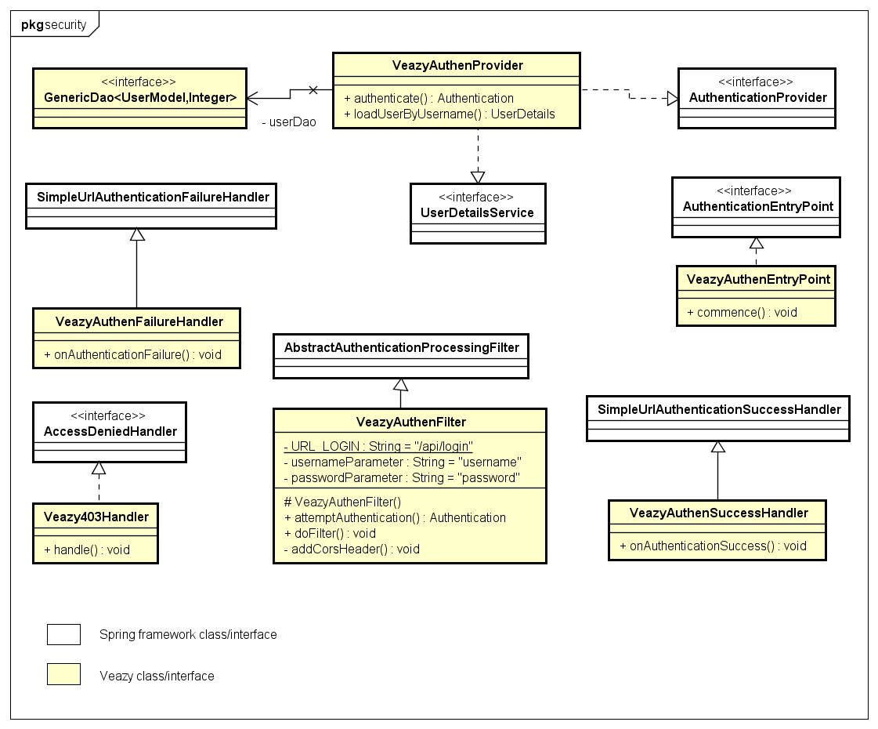

**Figure 8: Class diagram core.security package**

|  |  |  |
| --- | --- | --- |
| No | Class Name | Description |
| 1 | Veazy403Handler | Handles 403 forbidden error |
| 2 | VeazyAuthenEntryPoint | Handles anonymous requests |
| 3 | VeazyAuthenFailureHandler | Handles authentication failure requests |
| 4 | VeazyAuthenFilter | Filters authentication requests |
| 5 | VeazyAuthenProvider | Provides authentication mechanism |
| 6 | VeazyAuthenSuccessHandler | Handles authentication success requests |

### Veazy403Handler Class

#### Methods

|  |  |  |
| --- | --- | --- |
| No | Method | Description |
| 1 | handle() | Handles denied request |

### VeazyAuthenEntryPoint Class

#### Methods

|  |  |  |
| --- | --- | --- |
| No | Method | Description |
| 1 | commence() | Handles anonymous request |

### VeazyAuthenFailureHandler Class

#### Methods

|  |  |  |
| --- | --- | --- |
| No | Method | Description |
| 1 | onAuthenticationFailure() | Handles failed authentication event |

### VeazyAuthenFilter Class

#### Attributes

|  |  |  |  |  |
| --- | --- | --- | --- | --- |
| No | Attribute | Type | Note | Description |
| 1 | URL_LOGIN | String | private | Defines url string to filter the authentication request |
| 2 | usernameParameter | String | private | Defines the username parameter for UsernamePasswordAuthentication |
| 3 | passwordParameter | String | private | Defines the password parameter for UsernamePasswordAuthentication |

#### Methods

|  |  |  |
| --- | --- | --- |
| No | Method | Description |
| 1 | attemptAuthentication() | Attempts to authenticate the requested principal |
| 2 | doFilter() | Filters the authentication request |
| 3 | addCorsHeader() | Adds CORS header to response if needed |

### VeazyAuthenProvider Class

#### Methods

|  |  |  |
| --- | --- | --- |
| No | Method | Description |
| 1 | authenticate() | Authenticates the requested principal |
| 2 | loadUserByUsername() | Loads user details from requested principal |

### VeazyAuthenSuccessHandler Class

#### Methods

|  |  |  |
| --- | --- | --- |
| No | Method | Description |
| 1 | onAuthenticationSuccess() | Handles successful authentication event |

### Sequence Diagram

## core.service Package

### Class diagram

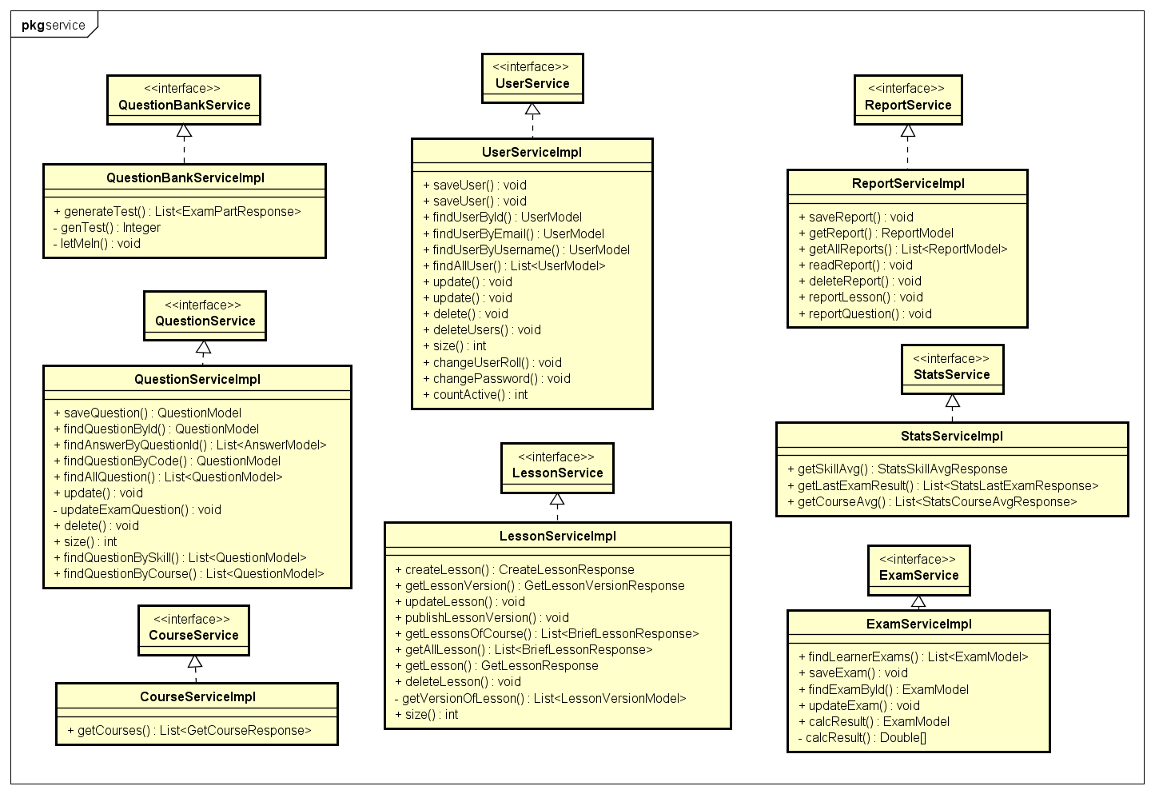

**Figure 9: Class diagram core.service package**

|  |  |  |
| --- | --- | --- |
| No | Class Name | Description |
| 1 | CourseServiceImpl | Contains business logical functions for processing course data |
| 2 | ExamServiceImpl | Contains business logical functions for processing test data |
| 3 | LessonServiceImpl | Contains business logical functions for processing lesson data |
| ~~4~~ | QuestionBankServiceImpl | Contains business logical functions for processing question bank data |
| 5 | QuestionServiceImpl | Contains business logical functions for processing question data |
| 6 | ReportServiceImpl | Contains business logical functions for processing report data |
| 7 | StatsServiceImpl | Contains business logical functions for processing statistic data |
| 8 | UserServiceImpl | Contains business logical functions for processing user data |

### CourseServiceImpl Class

#### Methods

|  |  |  |
| --- | --- | --- |
| No | Method | Description |
| 1 | getCourses() | Return list course |

### ExamServiceImpl Class

#### Methods

|  |  |  |
| --- | --- | --- |
| No | Method | Description |
| 1 | findLearnerExams() | Return all done exam of a user |
| 2 | saveExam() | Save an exam to database |
| 3 | findExamById() | Return an exam by its id |
| 4 | updateExam() | Update exam to database |
| 5 | calcResult() | Calculate exam result |

### LessonServiceImpl Class

#### Methods

|  |  |  |
| --- | --- | --- |
| No | Method | Description |
| 1 | createLesson() | Create new lesson |
| 2 | getLessonVersion() | Get a version of lesson |
| 3 | updateLesson() | Update a lesson |
| 4 | publishLessonVersion() | Make lesson as published version. Learner can see this lesson. |
| 5 | getLessonsOfCourse() | Return list lesson of a course. |
| 6 | getLesson() | Return a lesson. |
| 7 | deleteLesson() | Delete a lesson. |
| 8 | getAllLesson() | Return all lesson. |

### QuestionBankServiceImpl Class

#### Methods

|  |  |  |
| --- | --- | --- |
| No | Method | Description |
| 1 | generateExam() | Generates the exam response from the list of random questions |
| 2 | genExam() | Generates list of random questions |
| 3 | letMeIn() | Puts questions details to suitable list |

### QuestionServiceImpl Class

#### Methods

|  |  |  |
| --- | --- | --- |
| No | Method | Description |
| 1 | saveQuestion() | Save a question |
| 2 | findQuestionById() | Find a question by its id. |
| 3 | findAnswerByQuestionId() | Find all answer of a question by question id |
| 4 | findQuestionByCode() | Find a question by question code. |
| 5 | findAllQuestion() | Get all question. |
| 6 | update() | Update a question. |
| 7 | updateExamQuestion() | Update information of exam question what link to updated question. |
| 8 | delete() | Delete a question. |
| 9 | size() | Return the number of question in database. |
| 10 | findQuestionBySkill() | Find all question by a skill |
| 11 | findQuestionByCourse() | Find all question in a course |

### ReportServiceImpl Class

#### Methods

|  |  |  |
| --- | --- | --- |
| No | Method | Description |
| 1 | saveReport() | Save a report to database. |
| 2 | getReport() | Get a report. |
| 3 | getAllReports() | Get all report. |
| 4 | readReport() | Make a report as read state. |
| 5 | deleteReport() | Delete a report. |
| 6 | reportLesson() | User report a lesson. |
| 7 | reportQuestion() | User report a question |

### StatsServiceImpl Class

#### Methods

|  |  |  |
| --- | --- | --- |
| No | Method | Description |
| 1 | getSkillAvg() | Return average exam point for each skill of a user. |
| 2 | getLastExamResult() | Return last exam result of a user. |
| 3 | getCourseAvg() | Return average exam point for each course of a user. |

### UserServiceImpl Class

#### Methods

|  |  |  |
| --- | --- | --- |
| No | Method | Description |
| 1 | saveUser | Save new user. |
| 2 | findUserById | Find a user by id |
| 3 | findUserByEmail | Find a user by email |
| 4 | findUserByUsername | Find a user by user name |
| 5 | findAllUser | Get all user. |
| 6 | update | Update a user. |
| 7 | delete | Delete a user. |
| 9 | deleteUsers | Delete multiple user |
| 10 | size | Return the number of user in system. |
| 11 | changeUserRoll | Change user role |
| 12 | changePassword | Change user password |
| 13 | countActive | Return the number of active user |